Integrating Key Vault With App service

- Click on certificates option in App service and select Bring Your Own Certificate and click on Add certificate.
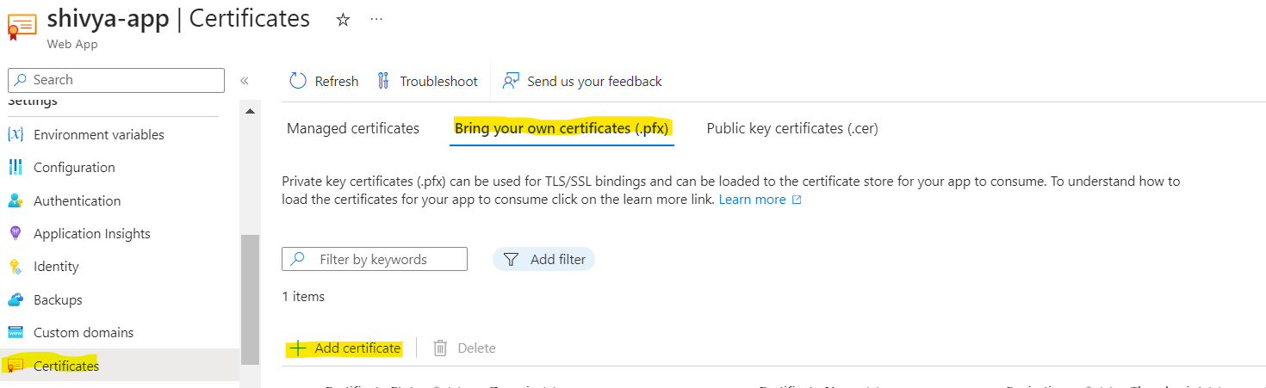

- Select Import From Key Vault in source option and click on Select Key Vault Certificate.
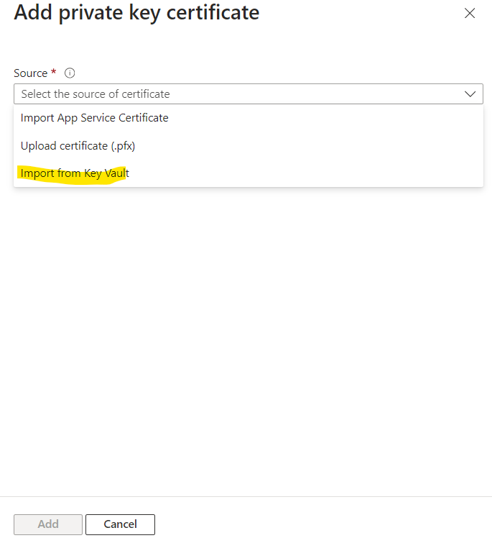
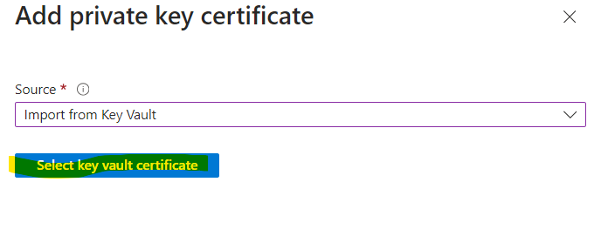
- Select the Subscription Name, Key-Vault Name and Certificate from drop down menu and click on Select option.
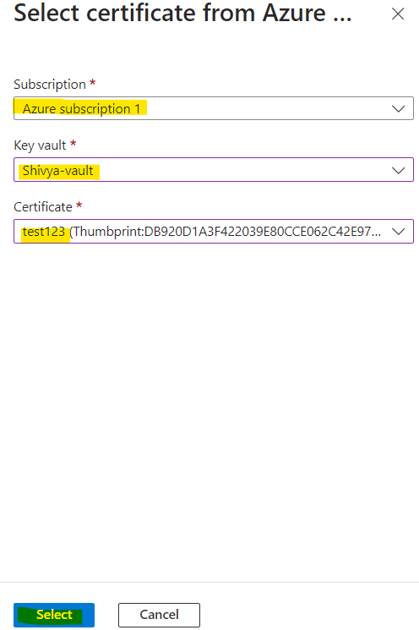

- Click on Validate Option.
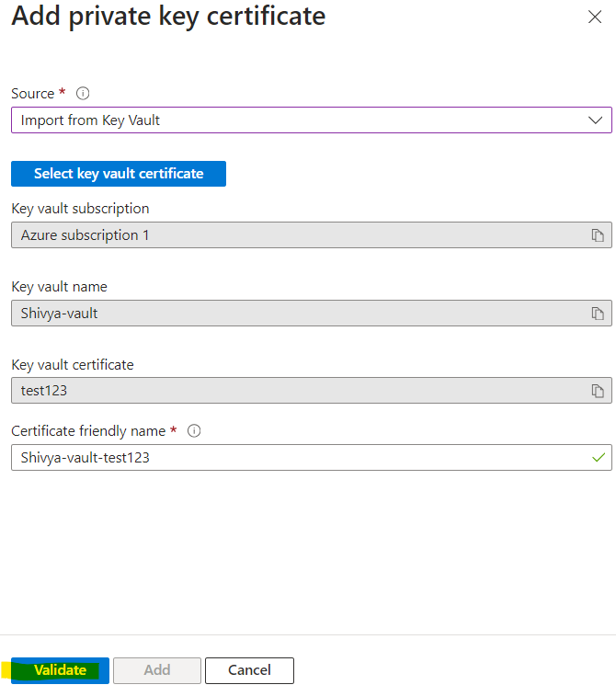

- Once Validation Completes, click on Add option.
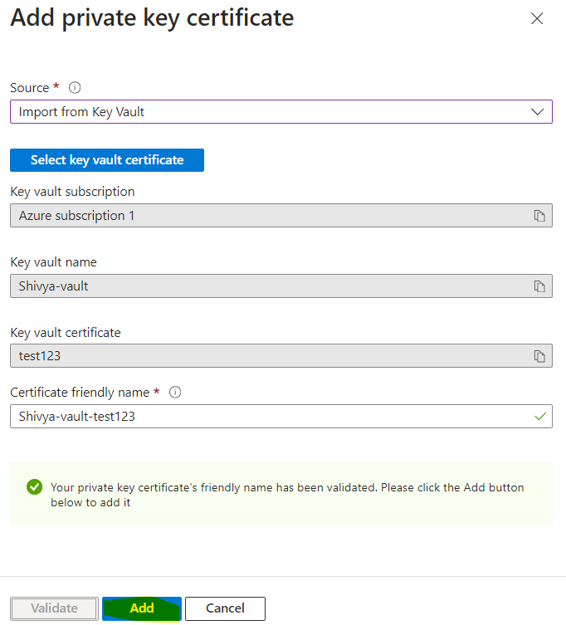

- Once you click on Add, your certificate will be visible in Bring Your Own Certificate page like below.
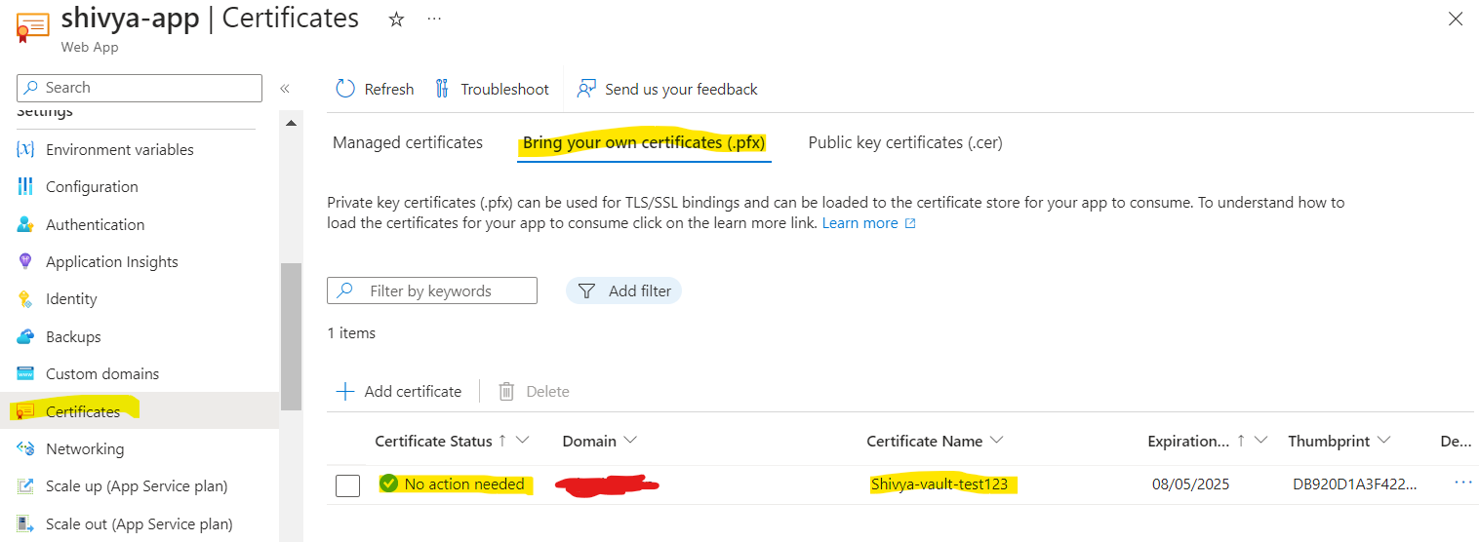

Binding SSL Certificate With Custom Domain:
- Click on Custom Domain option and select the Custom Domain on which you want to bind the SSL Certificate and click Add Binding.
